Damian Cisneros

CPE403 – FALL 2018

Tiva C Midterm

GOAL:

* Collect lux sensor data at intervals of 30 seconds for a period of 1 hour.
* Use an ESP8266 module to send to Thingspeak server.
* Use I2C interface for TSL sensor and UART interface for ESP8266.

DELIVERABLES:

Fully working project with all of the goals done. The project successfully gathers the data for the TSL291 and sends it to my Thingspeak where data is displayed as a line graph over time.

COMPONENTS:

TM4C123G LaunchPad

TSL291 (lux sensor)

NodeMCU w/ integrated ESP8266

VIDEO LINKS:

SCHEMATICS:

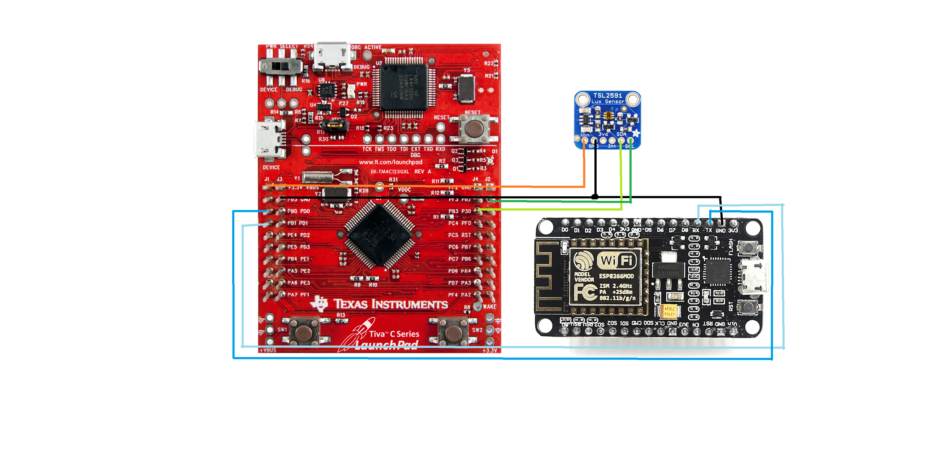

IIMPLEMENTATION:

1. UART1 is configured to be able to interact with ESP8266.
2. I2C is configured to be able to interact with the TSL2591.
3. TSL2591 is checked to see if it is able to interact with the master.
4. Hibernate settings are configured where it wakes up every 30s.
5. Average lux value is calculated.
6. TIVA C prints AT commands that allow the ESP8266 to connect to Thingspeak and send the average lux value.
7. Hibernate occurs and process repeats from step 1.

IMAGE OF SETUP:

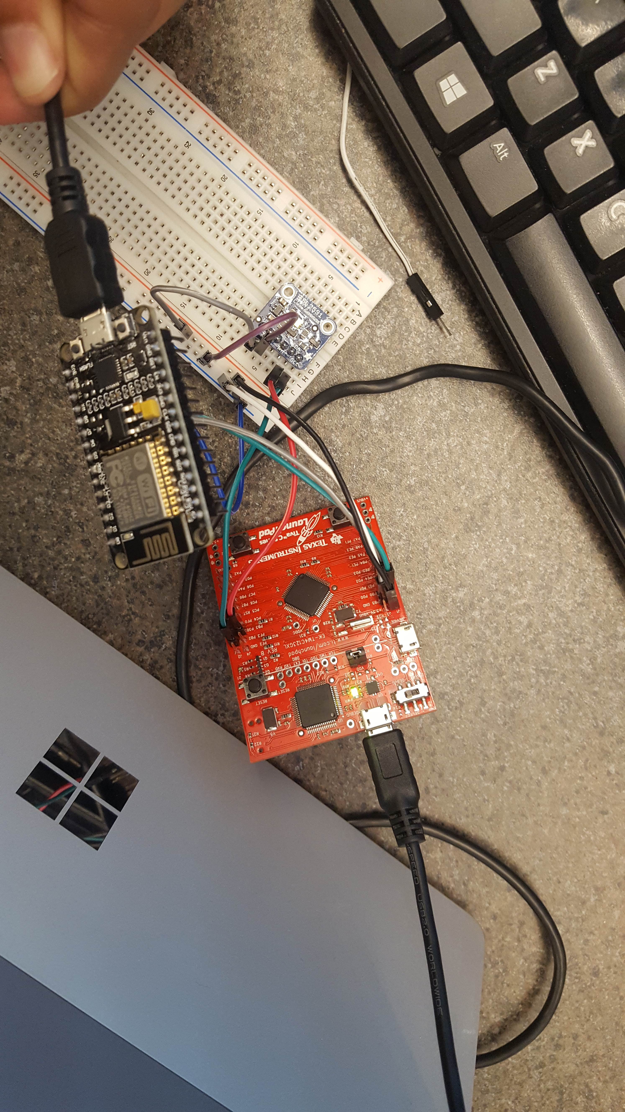

RESULTS:

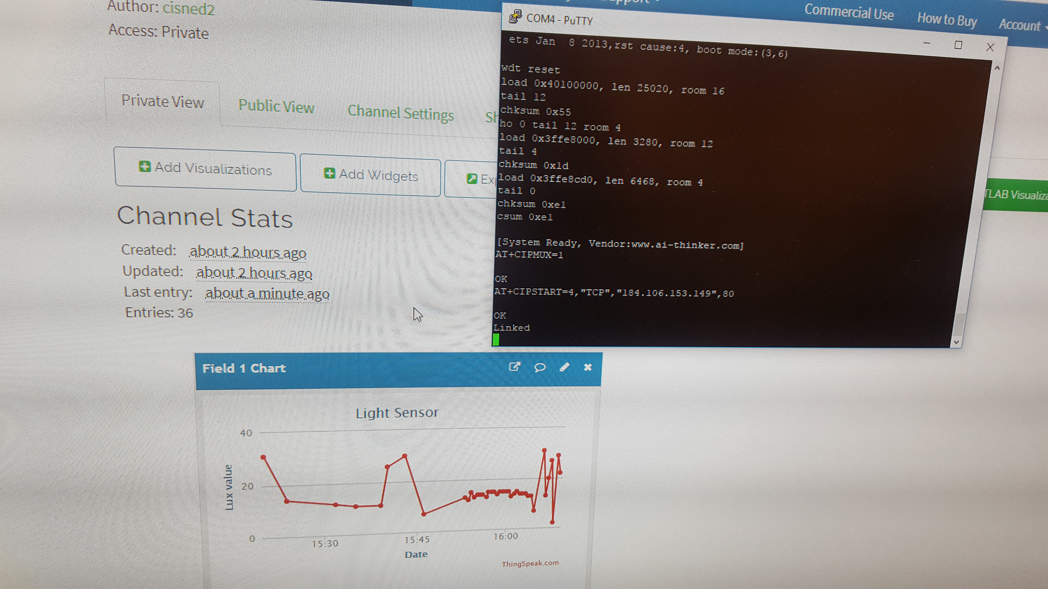

First few minutes of sending data. Image shows terminal working properly and data sending every 30 seconds.

CODE:

**#include** <stdarg.h>

**#include** <stdbool.h>

**#include** <stdint.h>

**#include** "inc/tm4c123gh6pm.h"

**#include** "inc/hw_i2c.h"

**#include** "inc/hw_memmap.h"

**#include** "inc/hw_types.h"

**#include** "inc/hw_gpio.h"

**#include** "driverlib/i2c.h"

**#include** "driverlib/sysctl.h"

**#include** "driverlib/gpio.h"

**#include** "driverlib/pin_map.h"

**#include** "driverlib/uart.h"

**#include** "utils/uartstdio.h"

**#include** "driverlib/interrupt.h"

**#include** "driverlib/hibernate.h"

**#include** "TSL2591_def.h"

**#include** "utils/ustdlib.h"

**void** **ConfigureUART**(**void**)

//Configures the UART to run at 19200 baud rate

{

**SysCtlPeripheralEnable**(SYSCTL_PERIPH_UART1); //enables UART module 1

**SysCtlPeripheralEnable**(SYSCTL_PERIPH_GPIOB); //enables GPIO port b

**GPIOPinConfigure**(GPIO_PB1_U1TX); //configures PB1 as TX pin

**GPIOPinConfigure**(GPIO_PB0_U1RX); //configures PB0 as RX pin

**GPIOPinTypeUART**(GPIO_PORTB_BASE, GPIO_PIN_0 | GPIO_PIN_1); //sets the UART pin type

**UARTClockSourceSet**(UART1_BASE, UART_CLOCK_PIOSC); //sets the clock source

**UARTStdioConfig**(1, 115200, 16000000); //enables UARTstdio baud rate, clock, and which UART to use

}

**void** **I2C0_Init** ()

//Configure/initialize the I2C0

{

**SysCtlPeripheralEnable** (SYSCTL_PERIPH_I2C0); //enables I2C0

**SysCtlPeripheralEnable** (SYSCTL_PERIPH_GPIOB); //enable PORTB as peripheral

**GPIOPinTypeI2C** (GPIO_PORTB_BASE, GPIO_PIN_3); //set I2C PB3 as SDA

**GPIOPinConfigure** (GPIO_PB3_I2C0SDA);

**GPIOPinTypeI2CSCL** (GPIO_PORTB_BASE, GPIO_PIN_2); //set I2C PB2 as SCLK

**GPIOPinConfigure** (GPIO_PB2_I2C0SCL);

**I2CMasterInitExpClk** (I2C0_BASE, **SysCtlClockGet**(), false); //Set the clock of the I2C to ensure proper connection

**while** (**I2CMasterBusy** (I2C0_BASE)); //wait while the master SDA is busy

}

**void** **I2C0_Write** (uint8_t addr, uint8_t N, ...)

//Writes data from master to slave

//Takes the address of the device, the number of arguments, and a variable amount of register addresses to write to

{

**I2CMasterSlaveAddrSet** (I2C0_BASE, addr, false); //Find the device based on the address given

**while** (**I2CMasterBusy** (I2C0_BASE));

va_list vargs; //variable list to hold the register addresses passed

va_start (vargs, N); //initialize the variable list with the number of arguments

**I2CMasterDataPut** (I2C0_BASE, va_arg(vargs, uint8_t)); //put the first argument in the list in to the I2C bus

**while** (**I2CMasterBusy** (I2C0_BASE));

**if** (N == 1) //if only 1 argument is passed, send that register command then stop

{

**I2CMasterControl** (I2C0_BASE, I2C_MASTER_CMD_SINGLE_SEND);

**while** (**I2CMasterBusy** (I2C0_BASE));

va_end (vargs);

}

**else**

//if more than 1, loop through all the commands until they are all sent

{

**I2CMasterControl** (I2C0_BASE, I2C_MASTER_CMD_BURST_SEND_START);

**while** (**I2CMasterBusy** (I2C0_BASE));

uint8_t i;

**for** (i = 1; i < N - 1; i++)

{

**I2CMasterDataPut** (I2C0_BASE, va_arg(vargs, uint8_t)); //send the next register address to the bus

**while** (**I2CMasterBusy** (I2C0_BASE));

**I2CMasterControl** (I2C0_BASE, I2C_MASTER_CMD_BURST_SEND_CONT); //burst send, keeps receiving until the stop signal is received

**while** (**I2CMasterBusy** (I2C0_BASE));

}

**I2CMasterDataPut** (I2C0_BASE, va_arg(vargs, uint8_t)); //puts the last argument on the SDA bus

**while** (**I2CMasterBusy** (I2C0_BASE));

**I2CMasterControl** (I2C0_BASE, I2C_MASTER_CMD_BURST_SEND_FINISH); //send the finish signal to stop transmission

**while** (**I2CMasterBusy** (I2C0_BASE));

va_end (vargs);

}

}

uint32_t **I2C0_Read** (uint8_t addr, uint8_t reg)

//Read data from slave to master

//Takes in the address of the device and the register to read from

{

**I2CMasterSlaveAddrSet** (I2C0_BASE, addr, false); //find the device based on the address given

**while** (**I2CMasterBusy** (I2C0_BASE));

**I2CMasterDataPut** (I2C0_BASE, reg); //send the register to be read on to the I2C bus

**while** (**I2CMasterBusy** (I2C0_BASE));

**I2CMasterControl** (I2C0_BASE, I2C_MASTER_CMD_SINGLE_SEND); //send the send signal to send the register value

**while** (**I2CMasterBusy** (I2C0_BASE));

**I2CMasterSlaveAddrSet** (I2C0_BASE, addr, true); //set the master to read from the device

**while** (**I2CMasterBusy** (I2C0_BASE));

**I2CMasterControl** (I2C0_BASE, I2C_MASTER_CMD_SINGLE_RECEIVE); //send the receive signal to the device

**while** (**I2CMasterBusy** (I2C0_BASE));

**return** **I2CMasterDataGet** (I2C0_BASE); //return the data read from the bus

}

**void** **TSL2591_init** ()

//Initializes the TSL2591 to have a medium gain,

{

uint32_t x;

x = I2C0_Read (TSL2591_ADDR, (TSL2591_COMMAND_BIT | TSL2591_ID)); //read the device ID

//UARTprintf("%lu\n", (unsigned long)x);

**if** (x == 0x50)

{

//UARTprintf ("GOT IT! %i\n", x); //used during debuging to make sure correct ID is received

}

**else**

{

**while**(1){};

}

I2C0_Write (TSL2591_ADDR, 2, (TSL2591_COMMAND_BIT | TSL2591_CONFIG), 0x10); //configures the TSL2591 to have medium gain adn integration time of 100ms

I2C0_Write (TSL2591_ADDR, 2, (TSL2591_COMMAND_BIT | TSL2591_ENABLE), (TSL2591_ENABLE_POWERON | TSL2591_ENABLE_AEN | TSL2591_ENABLE_AIEN | TSL2591_ENABLE_NPIEN)); //enables proper interrupts and power to work with TSL2591

}

uint32_t **GetLuminosity** ()

//This function will read the channels of the TSL and returns the calculated value to the caller

{

**float** atime = 100.0f, again = 25.0f; //the variables to be used to calculate proper lux value

uint16_t ch0, ch1; //variable to hold the channels of the TSL2591

uint32_t cp1, lux1, lux2, lux;

uint32_t x = 1;

x = I2C0_Read (TSL2591_ADDR, (TSL2591_COMMAND_BIT | TSL2591_C0DATAH));

x <<= 16;

x |= I2C0_Read (TSL2591_ADDR, (TSL2591_COMMAND_BIT | TSL2591_C0DATAL));

ch1 = x>>16;

ch0 = x & 0xFFFF;

cp1 = (uint32_t) (atime * again) / TSL2591_LUX_DF;

lux1 = (uint32_t) ((**float**) ch0 - (TSL2591_LUX_COEFB * (**float**) ch1)) / cp1;

lux2 = (uint32_t) ((TSL2591_LUX_COEFC * (**float**) ch0) - (TSL2591_LUX_COEFD * (**float**) ch1)) / cp1;

lux = (lux1 > lux2) ? lux1: lux2;

**return** lux;

}

**void** **main** (**void**)

{

**char** HTTP_POST[300]; //string buffer to hold the HTTP command

**SysCtlClockSet**(SYSCTL_SYSDIV_5|SYSCTL_USE_PLL|SYSCTL_XTAL_16MHZ|SYSCTL_OSC_MAIN); //set the main clock to runat 40MHz

uint32_t lux = 0, i;

uint32_t luxAvg = 0;

ConfigureUART (); //configure the UART of Tiva C

//UARTprintf ("TEST\n");

I2C0_Init (); //initialize the I2C0 of Tiva C

TSL2591_init (); //initialize the TSL2591

**SysCtlPeripheralEnable** (SYSCTL_PERIPH_HIBERNATE); //enable button 2 to be used during hibernation

**HibernateEnableExpClk** (**SysCtlClockGet**()); //Get the system clock to set to the hibernation clock

**HibernateGPIORetentionEnable** (); //Retain the pin function during hibernation

**HibernateRTCEnable** (); //enable RTC hibernation

**HibernateRTCSet** (0); //Set RTC hibernation

**HibernateRTCMatchSet** (0, **HibernateRTCGet**()+30); //hibernate for 30 seconds

**HibernateWakeSet** (HIBERNATE_WAKE_PIN | HIBERNATE_WAKE_RTC); //allow hibernation wake up from RTC time or button 2

**for** (i = 0; i < 20; i++)

//finds the average of the lux channel to send through uart

{

lux = GetLuminosity ();

luxAvg += lux;

}

luxAvg = luxAvg/20;

**UARTprintf** ("AT+RST\r\n"); //reset the esp8266 before pushing data

**SysCtlDelay** (100000000);

// UARTprintf ("AT+CWJAP=\"AndroidAP\", \"djaa2951\"\r\n");

// SysCtlDelay (100000000);

**UARTprintf** ("AT+CIPMUX=1\r\n"); //enable multiple send ability

**SysCtlDelay** (20000000);

**UARTprintf** ("AT+CIPSTART=4,\"TCP\",\"184.106.153.149\",80\r\n"); //Establish a connection with the thingspeak servers

**SysCtlDelay** (50000000);

//The following lines of code puts the TEXT with the data from the lux in to a string to be sent through UART

**usprintf** (HTTP_POST, "GET /update?key=3EDMW4MC3MNPSGN5&field1=%d&headers=falseHTTP/1.1\nHostapi.thingspeak.com\nConnection:close\Accept*\*\r\n\r\n", luxAvg);

**UARTprintf** ("AT+CIPSEND=4,%d\r\n", strlen(HTTP_POST)); //command the ESP8266 to allow sending of information

**SysCtlDelay** (50000000);

**UARTprintf** (HTTP_POST); //send the string of the HTTP GET to the ESP8266

**SysCtlDelay** (50000000);

**HibernateRequest** (); //Hibernate

**while** (1)

{**UARTprintf** ("%d",luxAvg);}

}

1. **SCREENSHOT OF EACH DEMO (BOARD SETUP)**

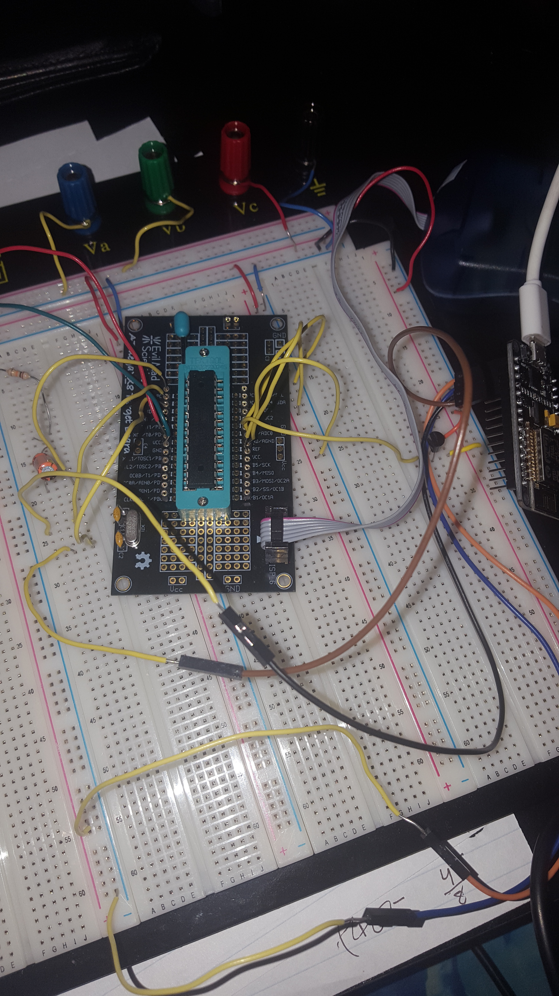

Task 1 C Board Setup

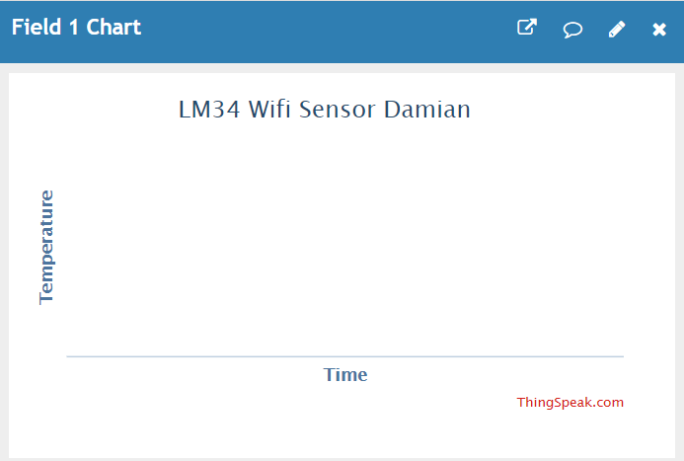

Task 1 Thingspeak data before code

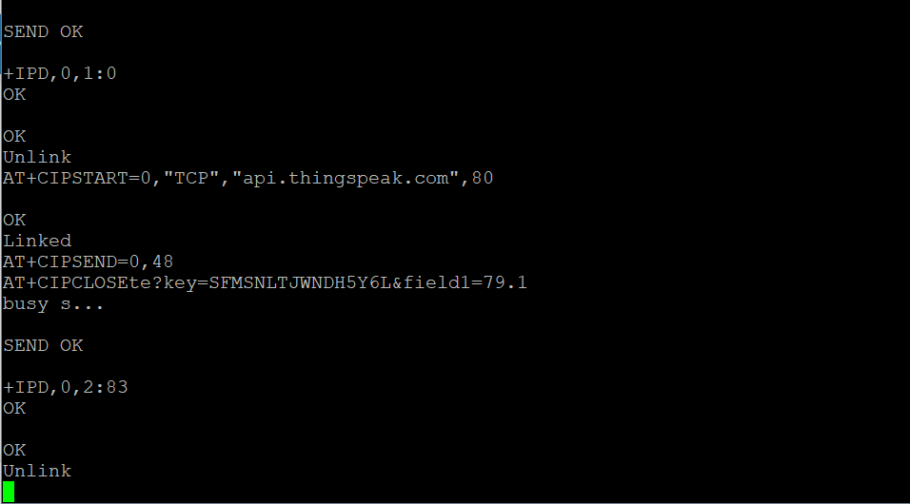

Task 1 AT commands correctly running and sending data

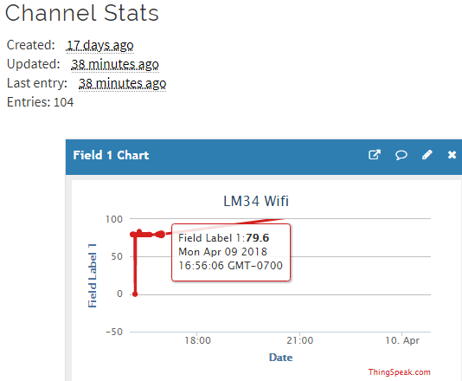

Task 1 Thingspeak data after, heated at end to show value changes

1. **VIDEO LINKS OF EACH DEMO**

Task 1/C Code - <https://youtu.be/0e3gMBXVGo0>

1. **GITHUB LINK OF THIS DA**

<https://github.com/cisned2/Midterm>

**Student Academic Misconduct Policy**

<http://studentconduct.unlv.edu/misconduct/policy.html>

“This assignment submission is my own, original work”.